**Application:** Weather Report App

**Author:** Harshit Shah

**Application Design:**

Weather application takes a zip code as an input from the user. Based on zip code, it will find out city, country, latitude and longitude details. Later using city and country it will obtain basic weather statistics. And further using latitude and longitude it obtains sunset-sunrise time details.

I have used 3 web services to obtain the current weather statistics.

1. **Google Geocoding API (Restful):**

URL: <https://developers.google.com/maps/documentation/geocoding/intro>

From the given zip code value, using Google’s Geocoding API it obtains city, country, latitude and longitude details.

API Request format: https://maps.googleapis.com/maps/api/geocode/output?zipcode&key=YOUR_API_KEY.

Required libraries in class path:

google-maps-services-0.1.11.jar

gson-2.3.1.jar

joda-time-2.4.jar

junit-3.8.1

okhttp-2.0.0.jar

okio-1.0.0.jar

1. **Global weather API (Soap WSDL)**

WSDL URL: <http://www.webservicex.net/globalweather.asmx?WSDL>

After getting city and country details, we will obtain the weather statistics like Location, Time, Sky conditions, Temperature, Relative Humidity, etc…

These details are received in xml response which is later on parsed using Java Dom parser.

1. **Sunrise-sunset API (Restful)**

API provider: <http://sunrise-sunset.org/api>

From the latitude and longitude details, we will next obtain the weather statistics like sunset time, sunrise time, length of the day, Civil twilight begin, Nautical Twilight begin and Astronomical Twilight begin.

API Request format: <http://api.sunrise-sunset.org/json?lat=latitude&lng=longitude>

The response is received in Json format which is parsed using Json library from org.json.

Required library in classpath:

json-20160212.jar

**Code Walkthrough:**

Weather app is a java web application which is developed on Netbeans 8.1.

1. index.jsp: starting page for the web application. It takes user input and sends to servelet.
2. WeatherFromZipServlet.java: Servlet class to handle http post and get request and response from the server.
3. WeatherFromZip.java: Main class which invokes web services.
4. response.jsp: Response page to display weather statistics to user.
5. error.jsp: Error page
6. style.css: Cascade Style Sheet to apply style on the pages.

**Screenshots of App:**

Homepage: <http://localhost:8080/WeatherFromZipWebApp/> or <http://localhost:8080/WeatherFromZipWebApp/index.jsp>

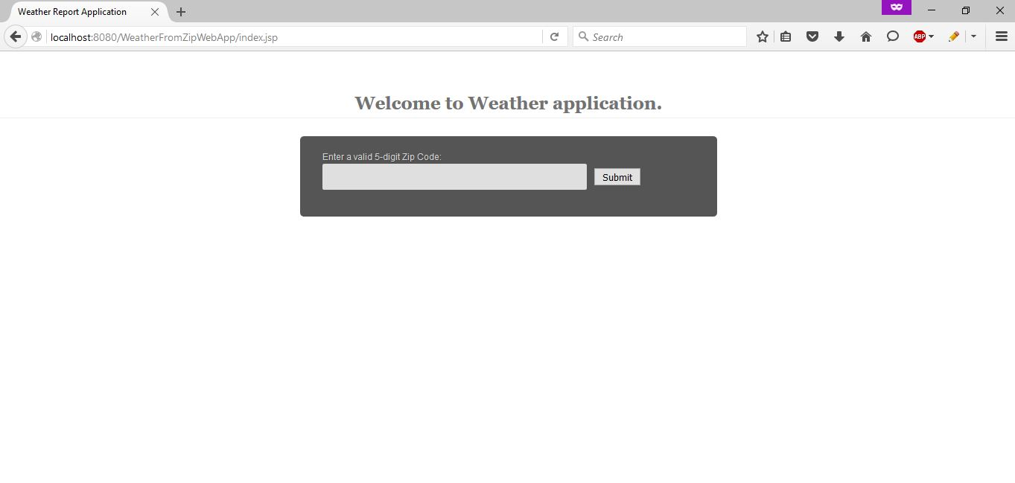

Entering proper 5-digit zip code (14623):

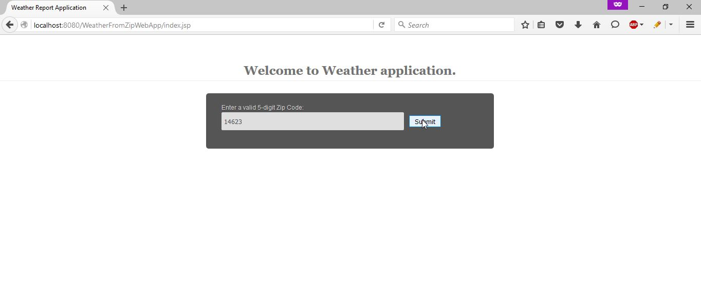

Weather statistics page: (part 1)

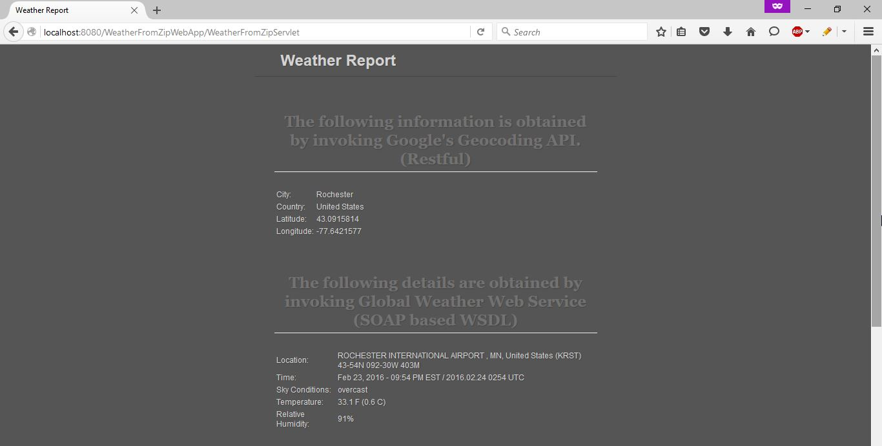

Weather statistics page: (part 2) scroll down



Entering wrong zip code (error page)

